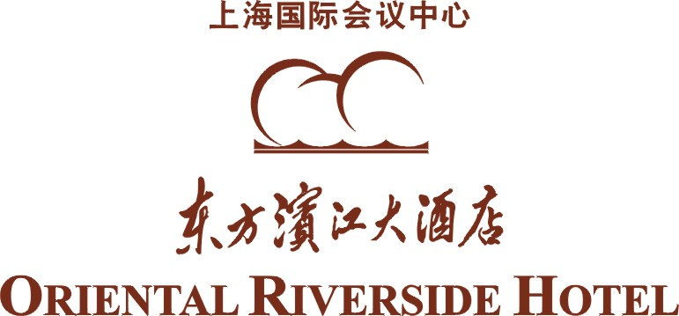

HOTEL BOOKING FORM
Event name: ISCAS 2026
Date：24May to 28May，2026
This Form must be completed and returned by every guest to hotel reservation dept by fax or E-mail. Please use one form per person.

- Hotel Room Reservation
Please return form to: | Company:
Reservation Department | Tel:
Contact person: Reservation | Fax:
No. 2727, Riverside Avenue Pudong, | E-mail:
Shanghai 200120 P. R. China | Booking guaranteed by (Visa / Master / )
Tel: (86) 21 50370000*6148/6151 | Name of Card Holder
Fax: (86) 21 50370051 | Credit Card No.
E-Mail: rs@shicc.net | Expiry:
Website: www.shicc.net | Signature:

Family Name: ___________________________First Name:____________________________

（ ）Superior Room Garden View-Twin bed  （ ）Superior Room Garden View-Twin bed | ----RMB 1100 (Inclusive of one BBF)  ----RMB 1270(Inclusive of two BBF)
（ ）Superior Room Bund View-King bed  （ ）Superior Room Bund View-King bed | ----RMB 1400 (Inclusive of one BBF)  ----RMB 1570(Inclusive of two BBF)
（ ）Superior Room Bund View-Twin bed  （ ）Superior Room Bund View-Twin bed | ----RMB 1400 (Inclusive of one BBF)  ----RMB 1570(Inclusive of two BBF)
（ ）Deluxe Room Bund View-King bed | ---RMB 1800(Inclusive of one or two BBF)

Check in date:_________________________Check out date____________________________
Remarks:
1. Your special rates are including 15% service charge。
2. 48 hours notice is required to cancel or amend a guaranteed booking. Otherwise, one
night room charge will be imposed as late cancellation penalty.
- In the event of any NO-SHOW, the guest shall be held responsibility for the payment which is equivalent to full length of stay.
- Please complete the reservation form and send to the hotel on or before May 20th 2026. All the reservation will be subject to room availability.

